4.3.5 Sorting Algorithms Problem Set Answer Sheet

This problem set requires you to use the skeleton program called Exercise 1. This is shown below and will be attached to the assignment post.

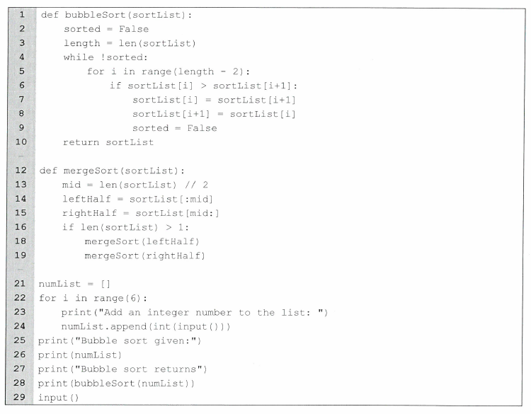
Instructions

This document is to be used as an answer sheet for the questions in the attached pdf file. This answer sheet has been designed to look similar to the AQA answer sheet used in the Paper 1 examination.

You will need to type or paste in screenshots/ screen captures of your code for the appropriate questions. For the questions with written answers you will need to type them in the appropriate space.

To hand in the work you will need to print off the work single sided and make sure your name is in the header part of the answer sheet.

Summary

Q | A1 | A2 | A3 | A4 | A5 | A6 | A7 | A8 | A9 | A10
Y
T | 1 | 1 | 1 | 1 | 1 | 2 | 2 | 2 | 2 | 2
Section A

Q No. | Answer | Your mark | Total mark
A1 | 1 |  | 1
A2 | 4 |  | 1
A3 | When a method or function calls iteself |  | 1
A4 | “!” is not valid python sytax it should be replaced with the keyword not |  | 1
A5 | Sorted gets set to false and not true so the while loop never ends |  | 1
A6 | It dosent store the value in a temporary variable it just overwrites it then copies the overwritten value |  | 2
A7 | Detecting when a progam encouters an error and either handeling it or shutting down gracefully. It create a much better user experance than the program crashing. |  | 2
A8 | Splitting up the list and pocsessing smal sections at a time |  | 2
A9 | Bubble: O( n^2 )  Merge sort: O(Nlog(N) |  | 2
A10 | Merge sort has a larger space complexity as it is reccursive. Bubble sort is smaller as it only uses itteration |  | 2

Next question starts on the next page
Question 1
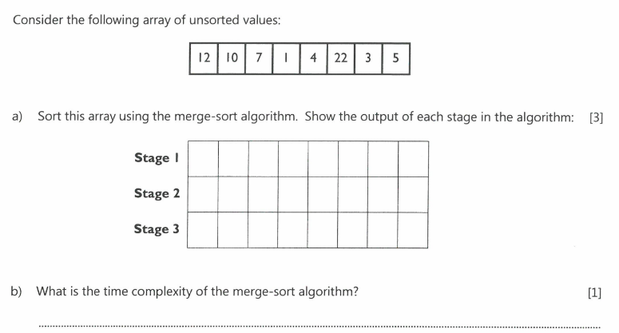

Question 2

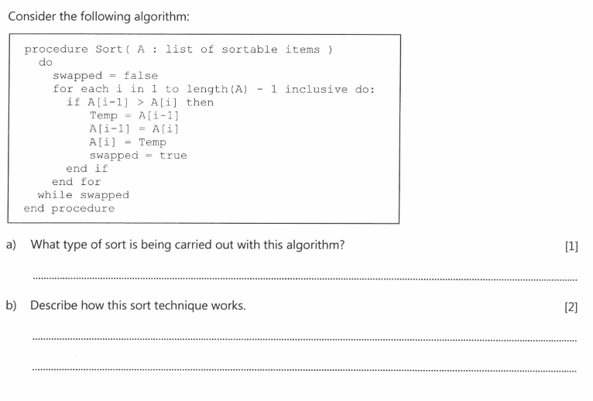

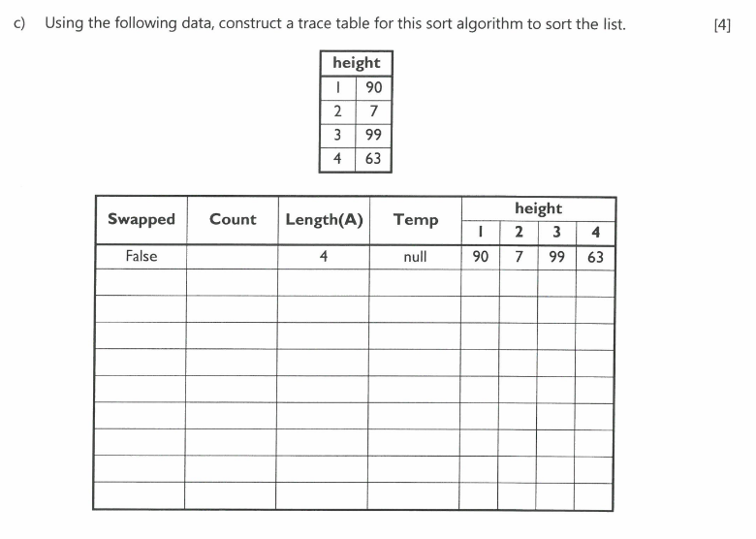
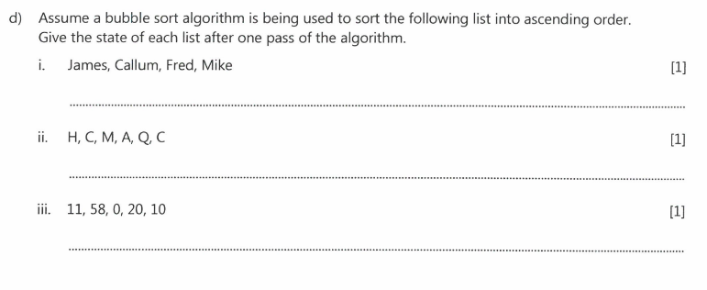
This is the end of the answer sheet.
Check that the printouts are readable.
Crop screen captures appropriately.
Make sure you print it off single sided and your name in the header of every page.

